Course work

“Pet accessories and toys store”

By: Taras Rybin

# MODEL DESCRIPTION

**LOGICAL SCHEME**

**product:** contains data about products which are selled in the store.

**product_category:** contains categories of products.

**pet_types:** contains pet types of products.

**bank_accounts:** contains bank accounts info of customers, suppliers and the store.

**customer:** contains data about customers.

**sales_order:** contains data of orders.  
**sales_line:** contains data of products selected in order.

**invoice:** contains data of payments for orders.

**invoice_line**: contains invoice data for each product of the order.

**finance_transaction**: contains data of all financial transactions made by store.

**inventory_transaction:** contains data of all products quantity changes in storage.  
  
**Create script is stored in courseWorkDBScript.sql  
Functions for main actions are stored in func.sql**

**Views script is stored in views.sql**

**DataBase name: courseWork.**

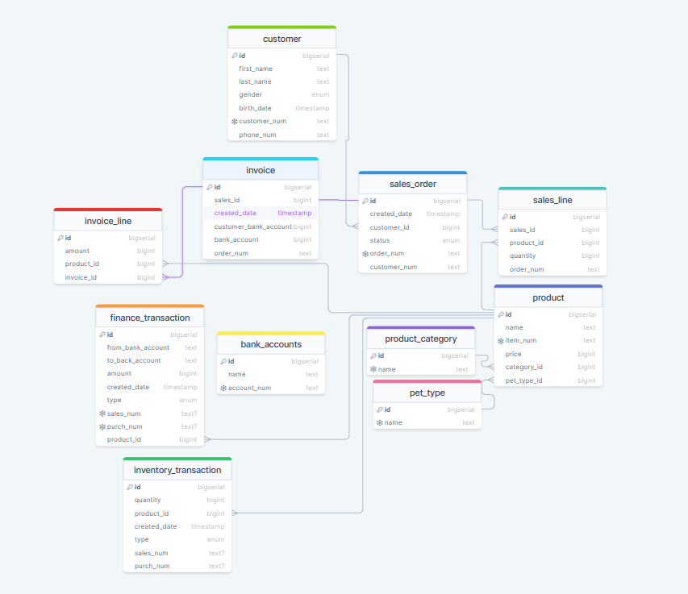

# 2.ETL TO DB DESCRIPTION

1. **DATA LOADING PROCESS**
2. DataSets are stored in *.csv files:   
   products.csv contains a dataset to create product, categories and pet_types data.

sales.csv contains a dataset of sales made in the store.

purchase.csv contains a dataset of the store purchasing gods for future retailing.

customers.csv contains a dataset of customers data

b) To load data from .csv files rerunable python scripts are used: products.py, sales.py, purchase.py, customers.py

d) To execute scripts create a PyCharm project, paste scripts files into the project directory, create directory “files” in the project directory and paste .csv files in it.

e) To connect to the database connection is used, so dbname, user, password and host parameters must be set for your db configuration.

f) Recommended order of execution: products.py -> customers.py -> purchase.py -> sales.py

Script does not rewrite the data which already exists in db.

# 3. DATA WAREHOUSE

**DataBase name: DWHcourseWork.**

Tables in DWH: product_dim, product_category_dim, pet_type_dim, customers_dim, bank_accounts_dim, fact_sales, fact_bank_balance, fact_product_sales.

Create script is stored in the file DWHTablesScript.sql.

# 4. ETL TO DWH DESCRIPTION

**1.** **DATA LOADING PROCESS**

**To load data into DWH stored procedure is used. Script : procedure.sql.(Rerunable) create procedure from script and then use the line with “call” from script to run it.**

# 5. Power Bi DESCRIPTION

Power Bi is connected to **DWHcourseWork.**

**report file: course_work.pbix**

**6.Using manual:**

**Create a database and use courseWorkDBScript.sql to create all tables.**

**Use ‘2.ETL TO DB DESCRIPTION’ to load data in the db.  
 Create views using views.sql.  
 Create and use(if needed) functions using func.sql.**

**Create a new db for DWH and use DWHTablesScript.sql to create tables.**

**Use procedure.sql to load data in created tables.  
Connect DWH db to powerBi and enjoy given report (course_work.pbix )**